ZOMATO SALES ANALYSIS 
KPI
1.Total Restaurant:-
SELECT count(RESTAURANTID) As Total_Restaurant FROM MAIN2;
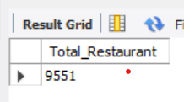
2.Total Country:-
SELECT count(distinct(COUNTRYname)) AS Total_country from country;
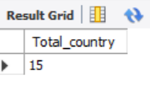
3.Total City:-
SELECT count(distinct(CITY)) AS Total_city from main2;
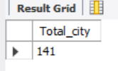
3.Total Votes:-
select sum(votes) as Total_vote from main2;
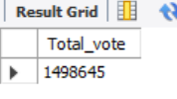
4.Average Rating:-
select cast(avg(RATING) as decimal(10,2)) AS Average_Rating from main2;
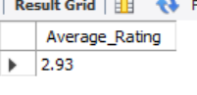
5.Total Cusines:-
SELECT count(distinct(CUISINES)) AS Total_Cusines from main2;
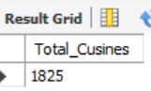
6. Total sales in USD:-
select cast(sum(Average_cost_for_two * usd_rate)as decimal(10,2)) as Total_sale_Usd from main2 inner join currrency on main2.currency=currrency.currency;
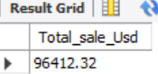
CHARTS
1.TOP 5 COUNTRY BASED ON VOTES :-
SELECT COUNTRYNAME , count(VOTES) AS Total_votes FROM MAIN2 INNER JOIN COUNTRY ON MAIN2.COUNTRYCODE=COUNTRY.COUNTRYID
group by COUNTRYNAME ORDER BY count(VOTES) DESC LIMIT 5;
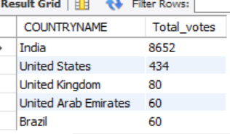
2. TOP 5 Restaurant based on Rating:-
SELECT RestaurantName , count(RATING) AS Total_Rating FROM MAIN2
group by Restaurantname ORDER BY count(Rating) DESC LIMIT 5;
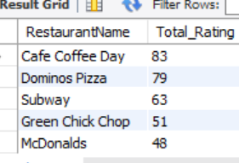
3. TOP 5 Cuisines based on Rating: -
SELECT CUISINES , count(RATING) AS Total_Rating FROM MAIN2
group by CUISINES ORDER BY count(Rating) DESC LIMIT 5;
